**DPU Update Script Design doc 1.0**

Contents

1. Description 1

2. Design 1

2.1. Architect 1

2.2. Command parameters 2

2.3. Normal output 2

2.4. Error List 2

2.5. Log and Debug 3

2.6. Limitations 4

3. Workflow 5

3.1. BMC firmware update 5

3.2. CEC Firmware update 5

3.3. ATF/UEFI firmware update 6

# Description

DPU update script is a program for updating various component firmware of Bluefield DPU, like BMC, CEC and BIOS(ATF&UEFI). It works from out of band, using Redfish API exposed by BMC of DPU. The script can work from any controller host (Linux), which has available connection to the DPU BMC system.

# Design

## Architect

The DPU Update Script works as following chart:

ARM OS

BMC

ATF/UEFI

DPU

Redfish(Restful) API

DPU Update  
Script

Controller Host

* DPU Update Script can run from any machine (Controller Host), which can establish connection to DPU BMC’s OOB interface.
* The script connects and manages the DPU through Redfish (Restful) API exposed by DPU BMC.
* The script is mainly implemented by Python3.

## Command parameters

OobUpdate.sh [-h] [-U <username>] [-P <password>] [-F <firmware_file>]

[-T <module>] [-H <bmc_ip>] [-C <clear_config>]

[-o <output_log_file>] [-p <bmc_port>] [-v]

[--skip_same_version] [-d]

optional arguments:

-h, --help show this help message and exit

-U <username> Username of BMC

-P <password> Password of BMC

-F <firmware_file> Firmware file path (absolute/relative)

-T <module> The module to be updated: BMC|CEC|BIOS

-H <bmc_ip> IP/Host of BMC

-C Reset to factory configuration (Only used for BMC|BIOS)

-o <output_log_file>, --output <output_log_file>

Output log file

-p <bmc_port>, --port <bmc_port>

Port of BMC (443 by default)

-v, --version Show the version of this script

--skip_same_version Do not upgrade, if upgrade version is the same as

current running version

-d, --debug Show more debug info

## Normal output

In normal successful case, the script will only have a few messages show in standard output. Like following:

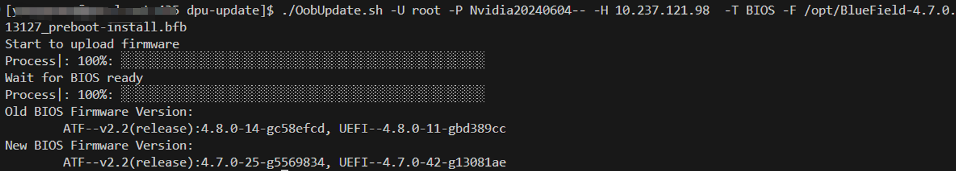

## Error List

While this script is running, errors may be encountered. Related error message will show in error output.



Following is error list the script may encounter:

|  |  |  |
| --- | --- | --- |
| Index | Error Name | Error Message |
| 1 | ARG_FOR_UPDATE_NOT_GIVEN | BMC IP/Username/Password, Firmware file path and Module are needed to do firmware update |
| 2 | FILE_NOT_ACCESSIBLE | File is not accessible |
| 3 | FW_FILE_NOT_MATCH_MODULE | Given firmware file is NOT for the Module to update |
| 4 | BMC_CONNECTION_FAIL | Failed to establish connection to BMC. Please check the BMC IP and port |
| 5 | BMC_CONNECTION_RESET | Connection to BMC being reset by remove |
| 6 | ACCOUNT_LOCKED | Account has been locked |
| 7 | INVALID_USERNAME_OR_PASSWORD | Invalid username or password |
| 8 | ANOTHER_UPDATE_IS_IN_PROGRESS | Another update is in progress; Please try to update the firmware later |
| 9 | UNSUPPORTED_MODULE | Unsupported updating module |
| 10 | BAD_RESPONSE_FORMAT | Bad response format |
| 11 | INVALID_STATUS_CODE | Invalid response status code |
| 12 | FAILED_TO_GET_LOCAL_KEY | Failed to get local SSH Key |
| 13 | FAILED_TO_ENABLE_BMC_RSHIM | Failed to enable BMC rshim; Please make sure rshim on Host side is disabled |
| 14 | NOT_SUPPORT_CEC_RESTART | CEC restart redfish API is not supported in this version; Please use power cycle of the whole system instead |
| 15 | BMC_BACKGROUND_BUSY | BMC is busy on background operation; Please try to update the firmware later |
| 16 | PUBLIC_KEY_NOT_EXCHANGED | Public key was not exchanged with BMC successfully |
| 17 | BIOS_FACTORY_RESET_FAIL |  |

## Log and Debug

There are some additional logs recording details of each restful request & response. Those logs can be used in debugging issues.

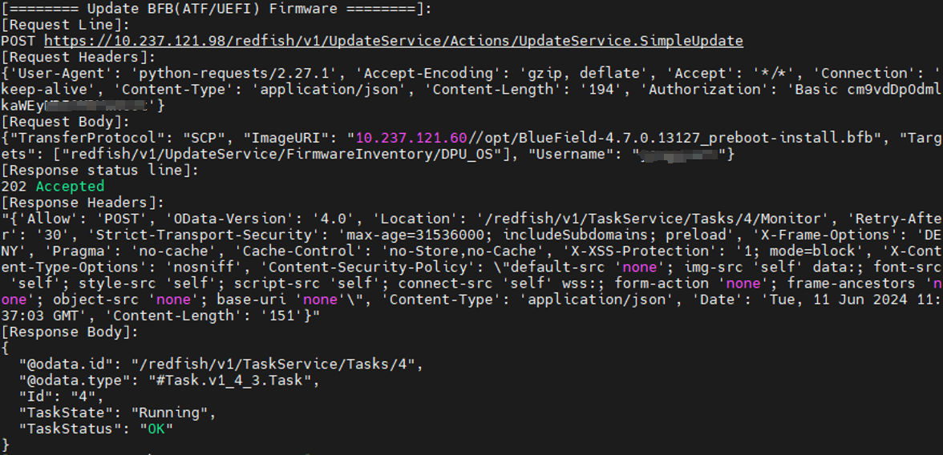

* If command has argument -d (--debug) , those additional logs will be shown in output
* If command has argument -o (--output_log_file), those additional logs will be written into the log file.

## Limitations

1. The script can only run on Linux host, with python3 installed
2. The rshim on Host side (in which DPU plugged) need to be disabled, if want to update BIOS firmware of DPU
3. The target DPU BMC version should be >= 24.04
   * Some redfish API may not be supported for earlier BMC versions.
   * That also means the script can only support >= Bluefield 3
   * The DPU BMC needs to be upgraded to >= 24.04 by other means, before using this script.
4. The default user/password of DPU BMC should be updated in advance.
5. For one DPU system, there can only be one update task at the one time. The later coming task will get “Another update is in progress" error.

# Workflow

# BMC firmware update

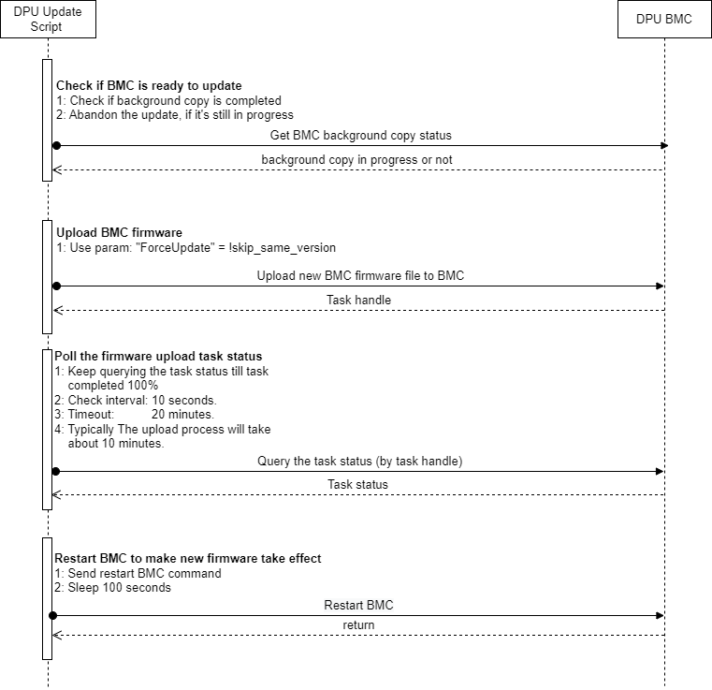

# CEC Firmware update

The CEC firmware update workflow is similar as BMC firmware update. Except for following:

1. The upload process will take less than 4 minutes
2. Will check task status every 2 seconds
3. Will wait 120 seconds, after CEC restart.

# ATF/UEFI firmware update

